# 

###### KURO – Information for invitation to tender



**Product:**

#### PE bends for cable protection – flexible 90°

Sand and mud proof, DIN 19537

Extremely pressure resistant, UV-resistance and impactresistance

# Information for invitation to tender:

|  |  |  |
| --- | --- | --- |
|  | Pos:....................... | PE flexible cable protection bends |
|  |  | with ring seal socket and plain end |
|  |  | 50 x 6,0 mm / long up to 90° / length = 1015 mm |
|  |  | Colour: black |
|  |  | System KURO o. glw. (www.kuro-kunststoffe.de), |
|  |  | supply and install, as an addition to pos: ........... |
|  |  |  |
|  |  | Amount:............Pieces UP: ....... TP: ........ |

|  |  |  |
| --- | --- | --- |
|  | Pos:....................... | PE flexible cable protection bends |
|  |  | with ring seal socket and plain end |
|  |  | 63 x 6,0 mm / long up to 90° / length = 1070 mm |
|  |  | Colour: black |
|  |  | System KURO o. glw. (www.kuro-kunststoffe.de), |
|  |  | supply and install, as an addition to pos: ........... |
|  |  |  |
|  |  | Amount:............Pieces UP: ....... TP: ........ |

|  |  |  |
| --- | --- | --- |
|  | Pos:....................... | PE flexible cable protection bends |
|  |  | with ring seal socket and plain end |
|  |  | 75 x 6,0 mm / long up to 90° / length = 1120 mm |
|  |  | Colour: black |
|  |  | System KURO o. glw. (www.kuro-kunststoffe.de), |
|  |  | supply and install, as an addition to pos: ........... |
|  |  |  |
|  |  | Amount:............Pieces UP: ....... TP: ........ |

|  |  |  |
| --- | --- | --- |
|  | Pos:....................... | PE flexible cable protection bends |
|  |  | with ring seal socket and plain end |
|  |  | 90 x 6,0 mm / long up to 90° / length = 1385 mm |
|  |  | Colour: black |
|  |  | System KURO o. glw. (www.kuro-kunststoffe.de), |
|  |  | supply and install, as an addition to pos: ........... |
|  |  |  |
|  |  | Amount:............Pieces UP: ....... TP: ........ |

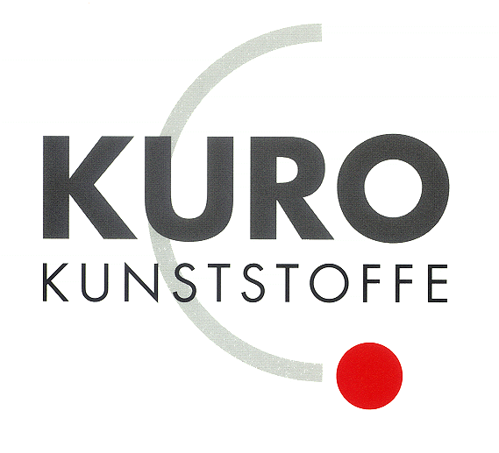

|  |  |  |
| --- | --- | --- |
|  | Pos:....................... | PE flexible cable protection bends |
|  |  | with ring seal socket and plain end |
|  |  | 110 x 6,0 mm / long up to 90° / length = 1685 mm |
|  |  | Colour: black |
|  |  | System KURO o. glw. (www.kuro-kunststoffe.de), |
|  |  | supply and install, as an addition to pos: ........... |
|  |  |  |
|  |  | Amount:............Pieces UP: ....... TP: ........ |

|  |  |  |
| --- | --- | --- |
|  | Pos:....................... | PE flexible cable protection bends |
|  |  | with ring seal socket and plain end |
|  |  | 125 x 6,0 mm / long up to 90° / length = 2080 mm |
|  |  | Colour: black |
|  |  | System KURO o. glw. (www.kuro-kunststoffe.de), |
|  |  | supply and install, as an addition to pos: ........... |
|  |  |  |
|  |  | Amount:............Pieces UP: ....... TP: ........ |

|  |  |  |
| --- | --- | --- |
|  | Pos:....................... | PE flexible cable protection bends |
|  |  | with ring seal socket and plain end |
|  |  | 140 x 6,0 mm / long up to 90° / length = 2100 mm |
|  |  | Colour: black |
|  |  | System KURO o. glw. (www.kuro-kunststoffe.de), |
|  |  | supply and install, as an addition to pos: ........... |
|  |  |  |
|  |  | Amount:............Pieces UP: ....... TP: ........ |

|  |  |  |
| --- | --- | --- |
|  | Pos:....................... | PE flexible cable protection bends |
|  |  | with ring seal socket and plain end |
|  |  | 160 x 6,0 mm / long up to 90° / length = 2275 mm |
|  |  | Colour: black |
|  |  | System KURO o. glw. (www.kuro-kunststoffe.de), |
|  |  | supply and install, as an addition to pos: ........... |
|  |  |  |
|  |  | Amount:............Pieces UP: ....... TP: ........ |